Project: Uhuru Training Centre

‘ A centre for vocational training for disadvantaged youth in Ghana’

Building a middle class

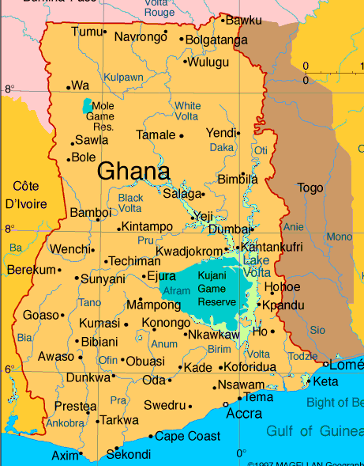

October 2018 Mariëtte Deijen
Amsterdam, The Netherlands
Abdul Mumuni Sidiq
Californie, US

Index

- Ghana in a nutshell page 3

- Goal / Mission page 4

- Introduction page 4

- Foundation Basic Care Ghana page 5

- Statement of need page 5

- Project description and objectives page 6

- Training courses page 7

- Plan of action page 7

- Recruitment plan page 7

- PR and marketing page 7

- Administrative data page 8

Appendix A: Content training courses page 9/10
Appendix B: Financing plan

GHANA in a nutshell
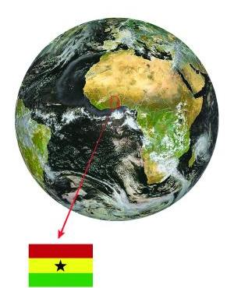
Rainforest, savanna and tropical beaches. On average it is 30 to 35 degrees Celsius. The country is easy to visit throughout the year. The green in the flag symbolizes the landscape. Ivory Coast is the left neighbor. Togo on the right. To the north lies Burkina Faso. The south is located on the Gulf of Guinea.
The old name is Gold Coast. The yellow in the flag symbolizes the wealth of minerals.
Cocoa and gold are the most important export products. Agriculture contributes 40% to the Gross National Product. Oil was found in 2007.
Ghana became independent in 1957. Before that it was a crown colony of England. The red in the flag symbolizes the blood of the people who fought for independence.
The black star in the flag represents African freedom. Ghana became the first West African country to become independent after the Second World War.

Accra is the capital and lies on the coast. There is also the international airport. Other big cities are: Kumasi, Tamale, Koforidua and Ho. Gouda, Amsterdam, Alkemade and Almere have city ties with Ghana. Approximately 24 million Ghanaians live on an area of ​​seven times the Netherlands. An estimated forty thousand live in the Amsterdam region The Voltameer provides electricity to the entire country. It is one of the largest reservoirs in the world.

The Ghanaian population is cheerful, outgoing, down-to-earth and hospitable. There is a lot of laughter and they take the day as it comes. The population makes a trip to Ghana to a peak.
Elephants, monkeys, hippos, antelopes and crocodiles can be admired. Other animals are also there, but they often hide.
Since 1992, two major political parties, NPP and NDC, have been fighting for political power. The current president since 2017 is Nana Akufo-Addo.
The 'Black Stars' are the national football heroes. Several players play in the Dutch league.
The official language is English. There are more than 45 native languages.
Paying goes with Cedi (GHS or GH ¢). The Cedi cent is called Pesawa (Gp). You have notes of ¢ 1, ¢ 5, ¢ 10, ¢ 20 and ¢ 50 and coins of ¢ 1 and Gp: 1, 5, 10, 20 or 50.

The country is predominantly Christian with an Islamic north. The African traditional faith is also widespread. The religions live tolerantly side by side.

Four out of five Ghanaians live on less than two dollars a day. The north is drier and poorer than the south. Around 35% of people in Ghana are short of food.

The inhabitants live mainly from street trade, but many have hardly any income. Due to lack of financial means, too little school education and the lack of finance for a follow-up education, there is hardly any future prospect for them.
In order to be able to provide for their maintenance, young people with fewer opportunities develop increasingly criminal activities and many teenagers go into prostitution.

Training and learning a profession is essential for having a real future in your own country and continent and therefore also for peace and happiness all over the world. This applies to every young person in the whole world, but especially to disadvantaged young people in countries where youth have less opportunities.

Goal / Mission
The realization of a practical training centre for young people without prospects. The Uhuru4all Foundation wants to give as many young people as possible the opportunity to follow a vocational training course, which greatly increases the chance of a meaningful working life for this group. As a result, the foundation expects young people to grow up healthier, happier and more peaceful in their own environment and amongs their own people, so that the immediate environment will also benefit from their education.
The mission of the Uhuru4all Foundation therefore consists of offering a future to Ghanaian youth with various vocational training courses.

Introduction

Uhuru 4 All Foundation is a non-profit organization that trains school leavers to learn a profession. We started with the sewing training.
The foundation was founded in 2007 and the first training in sewing started in Shukura (Accra), our initial location, which was a private location.
As the request of students were more than we could handle in Shukula we started another workshop in Galilee near Kasoa, where a church offered us a temporary space.
After that we rented a room for 1 year in Official Town until we finally bought a piece of land at Kojo Oku, a new area to be developed close to Nyanyano, which is now our permanent location.
There was an uncompleted building on the land we bought which we managed to complete for the sewing training. The workshop was able to accommodate about 10 students with the financing we had back then, but with the increase in the number of students (18 students on this project at the moment) we saw the need to expand.
There is room in front of the current building where we can place another building to create more space for our students plus start another vocational training.

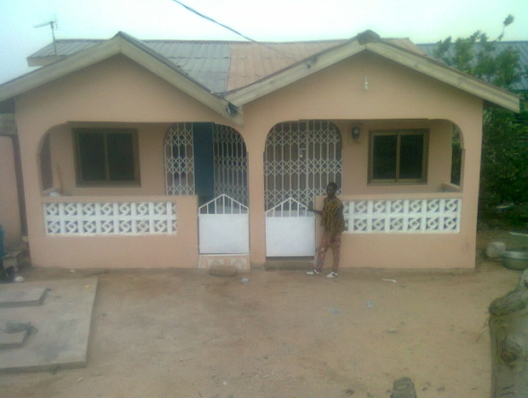
This is the building which was completely finished in 2016. In front of the workshop, the teacher Daniel Anabire Ayamga..

Basic Care Foundation (www.basiccareghana.nl)

Basic Care is a Foundation in the Netherlands that has supported us over the years since 2008 and has been our main support so far.
Since 2008 we have received an order for making clothes for the poor ones in the north who receives this as a gift at every Christmas party in the Shekinah clinic in Tamale.
With the help of this annual assignment, 12 students have already passed their exam at the NVTI (National Vocational Training Institute). They now work in different places and are able to maintain themselves and at the same time make a contribution to society.

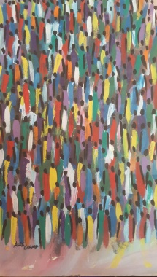
These are all future students in the NGO Uhuru4all. We hope that we can help them with the sewing training and a training to make Tie and Dye.

But first we have to build !!!!!

Statement of need
The foundation is looking for donations to expand our existing building with, among other reasons, the aim of offering all our students of the sewing vocation a shelter because our current space is not sufficient for the increased number of students. We currently have 18 students, some have to sit under a tree for training, due to the lack of space inside the building. Especially in the rainy season it is untenable to have their lessons outside.

We need a total amount of 21.446 euro. This is enough to build the structure we need and to purchase all the necessary equipments to able us offer the training we've planned.
We hope to provide a condusive environment for education with or without rain or sunshine. Our students are those who have motivated us to come up with this expansion project because of their seriousness and want to learn in all circumstances.
We have seen many lives change because they have completed the training and have been able to obtain their certificate. The vocational training has equipped them with a skill that will be useful to them and their families wherever they are. Our goal has always been to pave the way for the poor who had to drop out of school due to lack of funds because their parents did not have the resources to pay for their education. Instead of leaving them behind in the social vices (drug addiction, armed robbery, prostitution and all other vices) we have created this foundation to help by giving them the opportunity, and we have seen the results so far.

Project description and objectives
The idea to build the two-storey building is to create more space for our teeming students and maximize the use of the remaining land. The foundation for the building has already been laid as shown in the picture.
The layout of the ground floor would have two spaces, the back which will be bigger would serve as the extension of the sewing vocation and the smaller space in front as the commercial store front to generate some money for the sustainability of the foundation.
The space in the other building is suitable for 10 students and the extension would have space for another 10 students, so the students would not have to sit outside for their training.

The store will be selling clothes made by the teacher and the students, fabrics are also sold. The fabrics will come from the Tie and Dye vocational training, which is a new training that comes on the 1st floor. It is a course of 6 months where 10 students can be placed. In addition to fabrics and clothing, the store also sells sewing accessories, such as yarns, buttons, zippers etc. There is no store in this area that sells such things, we will therefore be meeting such needs of the people in the area. At present, one has to go to the village of Nyanyano or to the further away Kasoa.

At the back of the first floor will be a new professional training: the Tie and Dye training. This course is 6 months and 1o students can participate.
At the front a room/studio will be prepared to rent out.
This is intended to be a structural source of income for the Foundation in addition to the store, so that sustainability is created!
We have already started the project, the foundation of the building has already been laid.
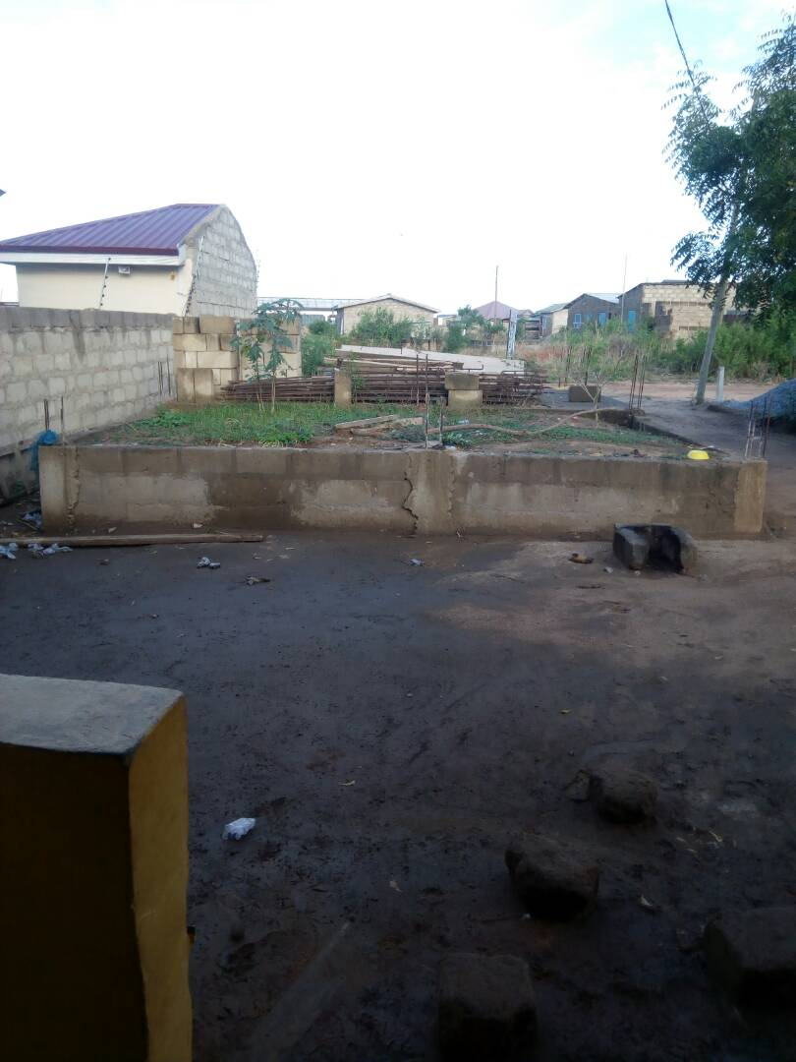
We hope that when completing the project, we will be able to accommodate about 20-25 students for one training cycle of the sewing course of two to three years.
In addition, 10 youngsters per 6 months who can follow the Tie and Dye training.

Training Courses

Sewing training

The sewing training lasts two to three years. There is 1 teacher and room for 10 students. After finishing the extra building there will be room for an extra 10 -15 students.
Exams Provision 1 and 2 for the tailor's certificate to be done at the NVTI
(National Vocational Trainings Institute)
Admission requirement: paying 200 GHC = 37 euros. A part is held separately by Daniel for the examination fee (for the NVTI). Furthermore, three pieces of clothing are made to wear as student outfit during the training.

BatikTraining

The students learn how to dye, make designs by drawing and how to use colours.
This takes half a year, has 1 teacher and has room for 10 students.

Plan of Action

Phase 1 March 2019 Construction of the ground floor> expansion of sewing course +
design shop
Phase 2 September 2019 Construction 1st floor
Phase 3 March 2020 Layout of all rooms

Recruitment plan

- Write to sponsor organisations
- Financial adoption of 1 trainee of 5.50 euro per month (studentship / travel allowance 3 euro per week plus health insurance 30 euro p.j = 2.5 euro p.w.)
- Monthly donation of 5.10, 25, 100 euros
- Publication of the project on different fundraising programs

PR & Marketing

- Website: www.Uhuru4all.org
- Page on Facebook.
- www.Geef.nl
- www.gofundme.org
- Business cards
- Flyers
- Festivals (Koningsdag Amsterdam, Panafest-festival).

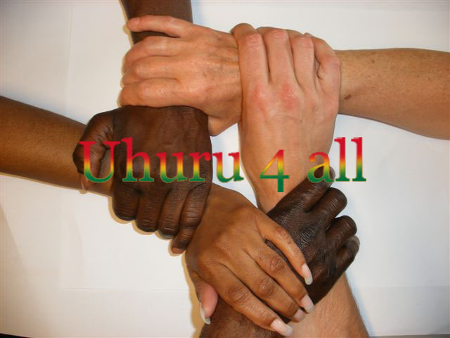

Your sponsorship contribution will be well utilized

ABN-AMRO account: NL 98 ABNA 081 771 936 9 o.v.v. Stichting Uhuru4all
(BIC:ABNANL2A)

Stichting Uhuru4all
Contactperson in Amsterdam: Contactperson in the US
Mariëtte Deijen Abdul Mumuni Sidiq
Saffierstraat 266, 1074 GZ te Amsterdam Oakland, Californie, US
Tel.nr.: + 31 (0)6-40795444 Tel.nr: + 1 510-827-7079
Email: mariettedeijen@gmail.com Email: abdulmumuni20@yahoo.com

Contactpersoon in Ghana:
Daniel Anabire Ayamga
Nyanyano Ghana
Tel: (+233) 24 953 1166
Email: anabireayamga@gmail.com

Stichting Uhuru4all
Notarized on 22 June 2007 and with its registered office in Amsterdam.
Registration Chamber of Commerce: 34276999.
Bank account ABN-AMRO: NL 98 ABNA 081 771 936 9 on the name of. Stichting Uhuru4all.
As of 1 January 2008, the Uhuru4all Foundation was designated by the Dutch Tax Administration (30985) as a General Benefit Organization (ANBI).

Website: www.uhuru4all.org

Appendix A : Content training courses

NGO UHURU 4 ALL
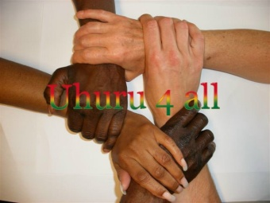

Workshop Email:
Kojo Oku anabireayamga@gmail.com
Near Nyanyano Website:
Tel: (+233) 24 953 1166 www.uhuru4all.org

Sewing Training

FIRST YEAR

- Learning of hand stitches
- Machine Stitch practice
- Making of Stitch Sampler
- Making of seams eg plain seam, French seam, welt seam etc
- Folding, marking out, cutting and joining of crossway strips.
- Sewing of vest and pant for a baby with shell edge.
- Sewing of cullotte and top for a child.
- Freehand cutting of bodice, skirt and sleeve.
- Drafting of the basic block patterns.

SECOND YEAR

- Adaptation of the bodice block pattern to variety of necklines
Making of specimens of necklines.
- Sewing of basic necklines, square, round, sweetheart, scoop.
- Sewing of skirts.
- Sewing of blouse
- Joining together skirt and blouse ie straight dress
- Making of table cloths, chair backs, coffee sets etc.
- Planning and sewing a night wear.
- Designing and sewing of a child’s dress.
- Arrangement of fullness gathers, pleats, tucks, darts, smocking, shirring etc.
- Openings
- Baby’s bootees and bonnet
- Sewing of kaba and slit
- Sewing of dinner dress
- Sewing of layette
- Design their own dress

Batik Training

- Dye fabric
- Making design
- Drawing a design
- Use different colours

