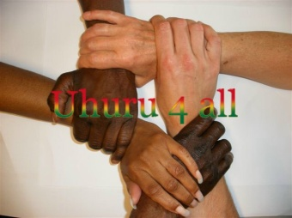
NGO UHURU4ALL
Office Email:
Gomoa Nyanyano Anabireayamga@gmail.com
Website:
Tel: (+233)249531166 www.uhuru4all.com
==============================================================================================

Order Basic Care

Date: 7 maart 2015
Estimate Order Basic Care

Extra amount: 1000,00 euro 3,754.00 GHC

15 trousers for men (1 trouser 24 ghc =2 yards) 360.00
15 shirts for men (1 shirt 14 ghc=2 yards) 210,00
25 children/boys trousers (1 trouser 18 ghc= 1 ½ yards) 450.00
25 shirts for children/boys ( 1 shirt 10,5 ghc = 1 ½ yards) 262.50
60 children/girls dresses (1dress 10,5 ghc=1 1/2 yards) 630.00
(Age 6-8-10-12)
30 long dresses for women (1 dress 21 ghc =3 yards) 630.00
Material for sewingcosts 391.97
Electricity (2 months a 55 cedis a month) 110.00
Machineoil (2 bottles a 20 cedis) 40.00
Transport Kasoa 50.00
Unforseen 619.53
_____________
Total 3,754.00 GHC

