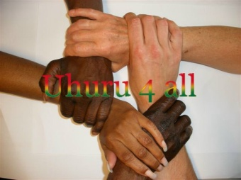
NGO UHURU4ALL
Office Email:
Gomoa Nyanyano Anabireayamga@gmail.com
Website:
Tel: (+233)249531166 www.uhuru4all.com
==============================================================================================

Order Basic Care

Date: 9 Febr 2015
Estimate Order Basic Care

Amount: 3500,00 euro 12,516.57 GHC

105 trousers for men (1 trouser 24 ghc =2 yards) 2, 520.00
105 shirts for men (1 shirt 14 ghc=2 yards) 1 470,00
50 children/boys trousers (1 trouser 18 ghc= 1 ½ yards) 900.00
50 shirts for children/boys ( 1 shirt 10,5 ghc = 1 ½ yards) 520,00
40 children/girls dresses (1dress 10,5 ghc=1 1/2 yards) 420.00
(Age 6-8-10-12)
30 long dresses fro woman (1 dress 21 ghc =3 yards) 630.00
Material for sewingcosts 1,306.57
Electricity (6 months a 55 cedis a month) 330.00
Machineoil (6 bottles a 20 cedis) 120.00
Transport Kasoa 120.00
Posting dresses 340.00
Salary Daniel (8 months a 480 cedis a month) 3,840.00
__________________
Total 12,516.57 GHC

