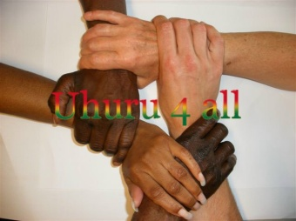
NGO UHURU4ALL
Office Email:
Nyanyano Anabireayamga@gmail.com
Oduponkpehe Website:
Tel: (+233)249531166 www.uhuru4all.com
==============================================================================================

Order Basic Care

Date: 9 mei 2016
Estimate Order Basic Care

Amount: 18.720.00 GHC

120 trousers for men (1 trouser 28 ghc =2 yards) 3,360.00
70 shirts for men (1 shirt 24 ghc=2 yards) 1,680,00
Tye & Dye
---
75 children/boys trousers (1 trouser 21 ghc= 1 ½ yards)
(age 3-8, Mariam?) 1,575.00
35 shirts for children/boys (age 3-8 )
Tye& Dye ( 1 shirt 18 ghc = 1 ½ yards) 630.00
---
35 children/girls dresses (age 3-8 )
Fleyr, Tye & Dye (1dress 24 ghc=2 yards) 840.00
----
15 shirts for young boys ( age 16,17,18)
( 1 shirt 24 ghc = 2 yards) 360.00
15 young girls dresses (age 16,17,18)
Fleyr (1 dress 36 ghc = 3 yards) 540.00
----
35 long dresses for women (1 dress 27 ghc =3 yards)
Tye & Dye (12 GHC =1 yard) 10 Pata pata (4 yards=48ghc) 480.00
Woodin ( 22GHC=1 yard) 10 Top Down (4yards=88ghc) 880.00
Tye&Dye (12GHC=1 yard) 15 long dresses Fleyr (4yards=48ghc) 720.00
------

Material for sewingcosts 1,725.00
Electricity (6 months a 60 cedis a month) 360.00
Machineoil (6 bottles a 22 cedis) 132.00
Transport Kasoa 180.00
Posting dresses 350.00
Salary Daniel (8 months a 500 cedis a month) 4.000.00
(Bank 913.00)
__________________
Total 18.725.00 GHC
= 400 pieces

Daniel received on 19 febr 18.720,00 GHC

