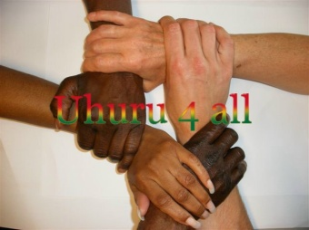
NGO UHURU4ALL
Office Email:
Nyanyano Anabireayamga@gmail.com
Oduponkpehe Website:
Tel: (+233)249531166 www.uhuru4all.com
==============================================================================================

Order Basic Care

Date: 19 march 2017
Estimate Order Basic Care

Amount: 21.060.00 GHC

90 trousers for men (1 trouser 36 ghc =2 yards) 180 yards 3,240.00
90 shirts for men (1 shirt 24 ghc=2 yards) 180 yards 2,160.00
Tye & Dye
--------------------------------------------
40 children/boys trousers (1 trouser 27 ghc= 1 ½ yards) 60 yards 1,080.00
(age 3-8)
50 shirts for children/boys (age 3-8 )
Tye& Dye ( 1 shirt 18 ghc = 1 ½ yards) 75 yards 900.00
-------------------------------------------
20 trousers for young boys ( age 16-18)
(1 trouser 36 ghc = 2 yards) 40 yards 720.00
20 shirts for young boys ( age 16-18)
(1 shirt 24 ghc = 2 yards) 40 yards 480.00
--------------------------------------------
20 young girls (age 3-8)
Fleyr, Tye & Dye (1 dress 24 ghc=2 yards) 40 yards 480.00
-------------------------------------------
15 young girls dresses ( age 16-18)
Fleyr (1 dress 36 ghc=3 yards) 45 yards 540.00
------------------------------------------
50 long dresses for women
Tye & Dye (12 GHC =1 yard) 15 Pata pata (4 yards=48ghc) 60 yards 720.00
Woodin ( 25GHC=1 yard) 15 Top Down (4yards=100ghc) 60 yards 1,500.00
Tye&Dye (12GHC=1 yard) 20 long dresses Fleyr (4yards=48ghc) 80 yards 960.00
--------------------------------------------

Material for sewingcosts 2,000.00
Lining 1 yard = 2 GHC ( only for Woodin top/down 15x4 yards=60 120.00
Electricity (8 months a 90 cedis a month) 720.00
Machineoil (6 bottles a 24 cedis) 144.00
Transport from Kasoa (with fabrics) and to STC (with the clothes) 150.00
Posting dresses with the STC 350.00
Salary Daniel (8 months a 550 cedis a month) 4.400.00

__________________
Total
= 390 pieces 20,664.00 GHC

Contingency expenses 396.00

Daniel received on 3 March 21.060.00 GHC

