**Annual report 2013**

**NGO Uhuru4all Ghana**

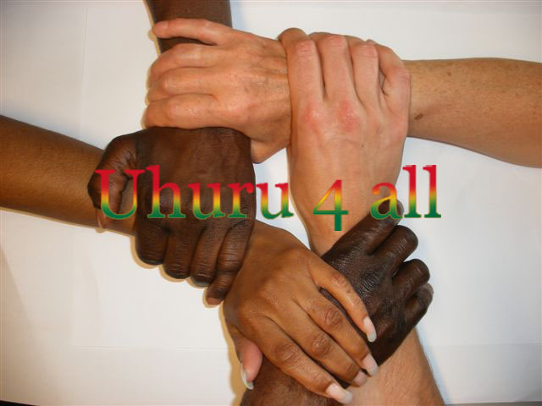

__________________________________________________________________________________

Kamer van Koophandel: 34276999 Stichting Uhuru4all

Amsterdam Saffierstraat 266

1074 GZ Amsterdam

Email: [mariettedeijen@gmail.com](mailto:mariettedeijen@gmail.com)

[www.uhuru4all.org](http://www.uhuru4all.org)

**Foreword by the chairman**

Fortunately, after five and a half years from the start of the first sewing workshop in Shukura Accra, the start of a second sewing workshop, which had to be moved twice, we finally found a few sponsors.

The first sewing workshop was paid from private finances and now we can look for a final location for the second sewing workshop. Unfortunately, in recent years I have had to decide to end the sewing workshop in Shukura as the conditions of our sewing training were not worked with.

During this period, two trainees completed the full training in Shukura, unfortunately without an exam. However, under the harsh conditions of the second sewing workshop, which also had to be moved during that period, 6 trainees managed to pass their exam at the NVTI (National Vocational Training Institute) under the inspiring and professional guidance of tailor Daniel Anabire Ayamga.

A true achievement!

At the end of 2013, we were finally able to start a small but final location for the sewing training in Kojo Oku, near Nyanyano.

Mariette Deijen

Chairman of the Uhuru4all Foundation

**Content**

1. Activities page 4
   1. Visit Ghana March
   2. Visit Ghana November
2. Future page 8
3. Organisation page 8
4. Board Ghana page 8
5. Financial report 2013 page 9
6. **Activities**

**1.1 Visit Ghana 2 weeks March 2013**

The first priority after receiving the donation from Rabo Share4more is to look for a permanent location for the sewing training.

Within a week we were lucky enough to find a piece of land with an unfinished building on it, in an area to be developed, about 25 kilometres outside Accra, Kojo Oku near Nyanyano.

After a lot of negotiation, the price was asked of € 4222, -

The purchase wasn’t easy in achieving, since the official registration of this piece of land in Cape Coast had to be done first. This would certainly take several weeks. There was no time, in connection with the return journey, to wait for this.

To make sure that after payment this would actually be registered in the name of the Foundation, we went to the High Court of Justice in Accra to have an official judicial document made as proof of ownership before we would receive an official proof of registration in Cape Coast.

After this was done, this was arranged in 3 days, payment has been made!

This is the front view:

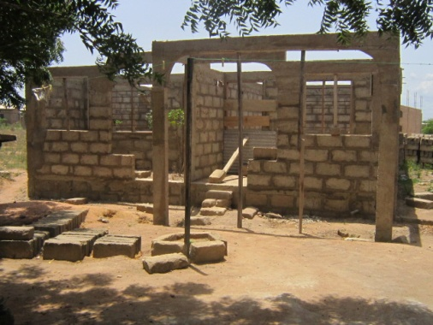In connection with the finances, it was decided to finish only half of the building for the sewing workshop.

A budget was requested from three contractors. Ultimately, the contractor was chosen, who was the previous owner of this piece of land + building.

Daniel, the tailor will finish the other half of the building in due time, if he has money, so he can live there.

**1.2 Visit Ghana two weeks in November**

The reason for this visit is to complete the project, the new sewing workshop in Kojo Oku. This was made possible by the Hofstee Foundation, which made the Uhuru4all Foundation a donation of 2000 euros.

This amount was requested to prepare the workshop for this training centre for young people who want to follow tailor training[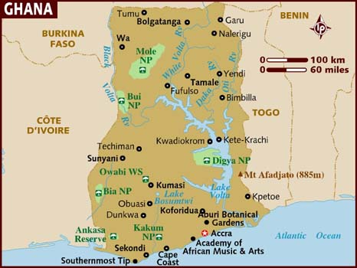](http://www.lonelyplanet.com/destinationRedirector?openMap=true&ethylCobjId=1013)

First, we went after the land ownership documents as they still hadn't come back. That was a task, but with the help of the Chief of Gomoa, the papers were found and signed by the Chief within a week.

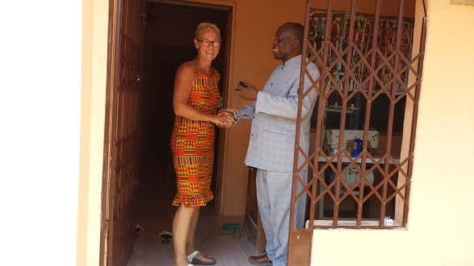

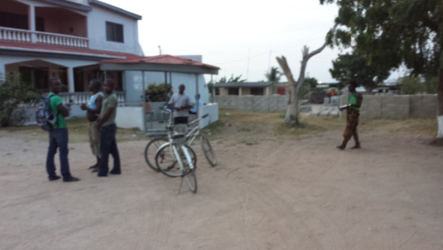Left: the Palace of the Chief!

Right: Chief Nana of Gomoa

The piece of land is now in the name of the NGO Uhuru4all.

After that, we focused on what it took to finish the building. 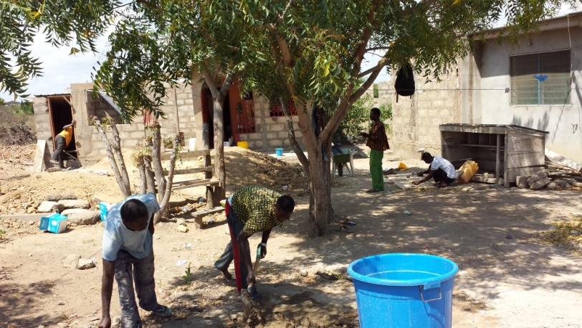

When I came in November I found this:

On the far left the toilet block.

We started laying a floor, then the plasterwork, the roof was put on, electricity was installed. The door and windows were put in, with burglars fencing in front of it. A ceiling has been installed, which apparently works very well against the entry of the mosquitoes!

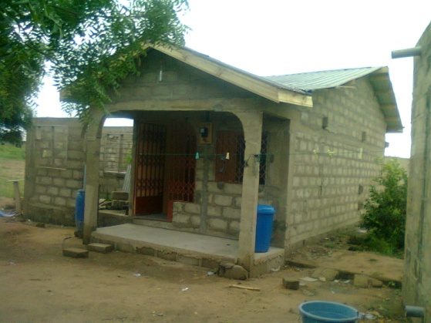There was still some work to be done on the inside and outside of the workshop !!

Daniel, the tailor and I, have started compiling a list of the work that has to be done and the things that still had to be purchased.

After this action:

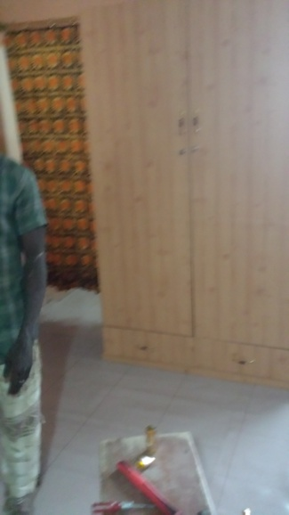The toilet building had to be finished, floor, walls painted. The dressing room in the workshop had to be made. Fans, linoleum, sewing machines had to be bought. The carpenter was commissioned to make a cupboard to store the fabrics and all sewing equipment.

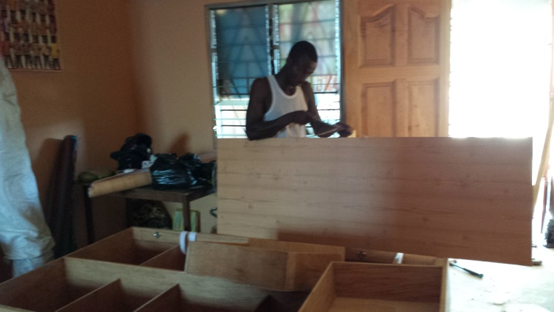

Carpenter at work

The fans and the clock are hung up

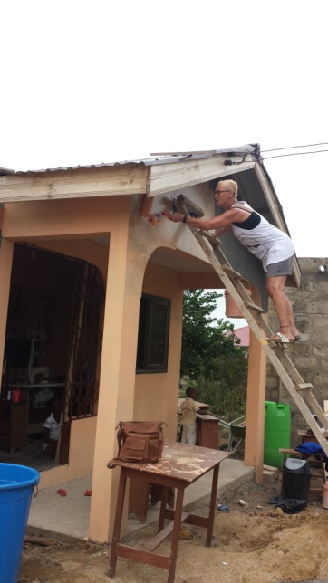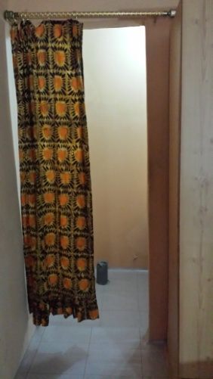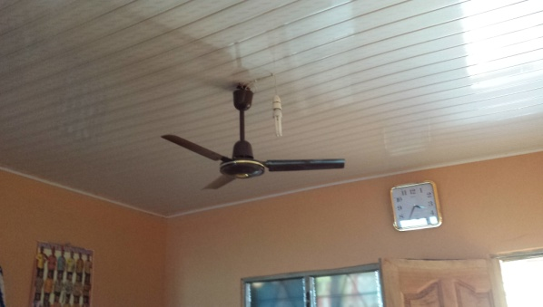

The fitting room ready! The front, the fence painted, the window attached.

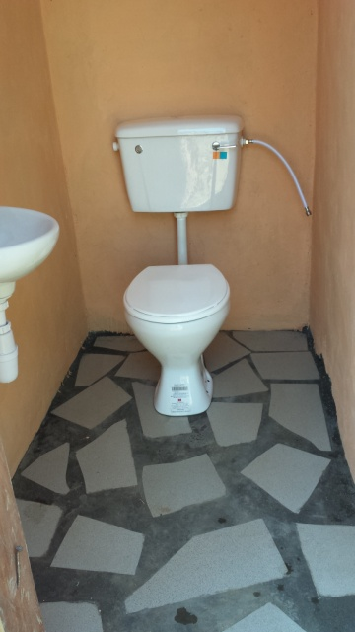

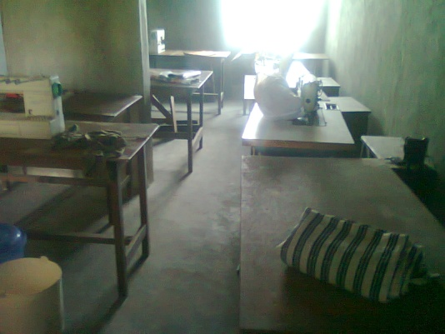Toilet finished!

For 9 consecutive days, a lot of effort has gone into getting everything ready by the mason, the carpenter, the plumber and last but not least ourselves.

On Tuesday, November 26, it was time to put all tables with sewing machines in place, to make the workshop neatly for use so that the 4 trainees could start their training on Wednesday.

No sooner said than done and see here the result of all efforts.

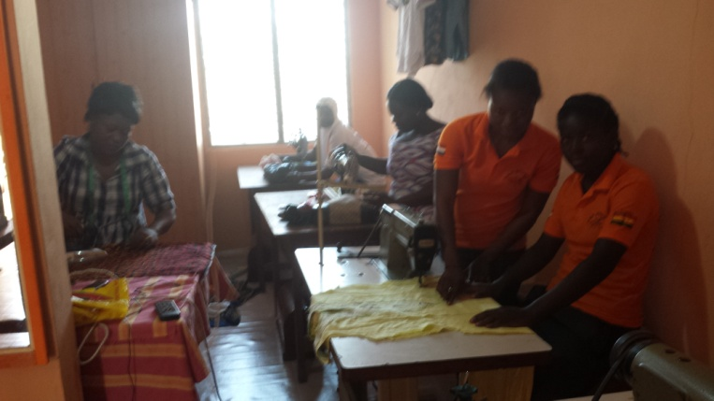The front of the workshop. The interns at work.

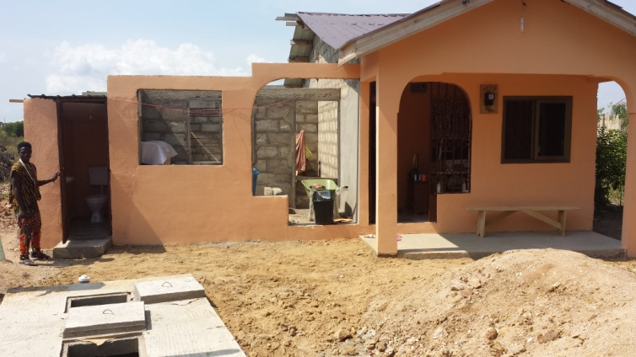

The teacher teaching....

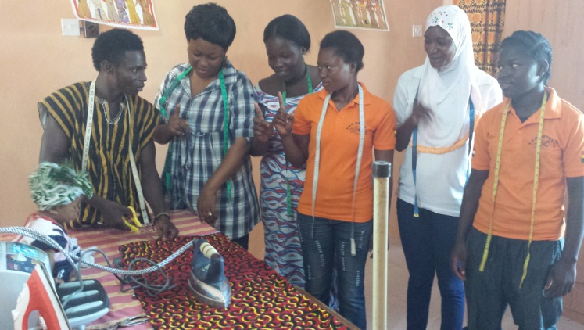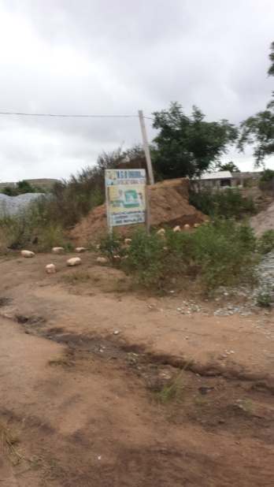

Path to the workshop

A new intern registered that Wednesday, and now one last intern can be placed to do the training.

In less than 1 ½ week we managed to prepare the workshop in- and outside to start the course.

From now on Daniel can start with the second training of trainees to teach them the tailoring profession!

I could return home with confidence!

Daniel can now start with the annually recurring assignment of the Basic Care Foundation to make clothing for Dr. David Abdulai from the Shekinah clinic. This clothing is intended as a Christmas present for the poor people in Tamale.

This assignment of a few hundred pieces of clothing is a good base for the training. It concerns ladies, gentlemen and children's clothing.

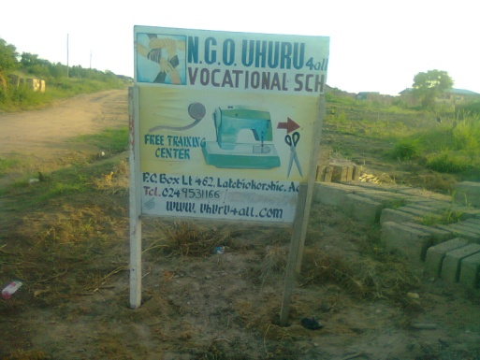

Recruiting students has also started. This sign has been placed to announce the start of a Vocational School

In the past two years, 6 students have been able to follow the sewing training and took their exams in March 2013 at the NVTI (National Vocational Training Institute).

They all passed.....

1. **Future**

After I got home I decided that I wanted to take a time-out, now we have a final location for the sewing workshop.

Apart from the annually recurring order from the Basic Care Foundation, of which I made the budget and distribution of the clothing, it was not necessary to be involved with the Foundation.

I could confidently leave the training to Daniel, the teacher.

The goal was reached!

The last few years had been very tough as many disputes and bad decisions were made by the Board in Ghana.

That is why I have indicated to the members of the Board in Ghana that I no longer wished to use their services.

I also said goodbye to the members of the Board in the Netherlands.

1. **Organisation**

NGO Uhuru4all

Chairman Mariette Deijen

Saffierstraat 266

1074 GZ Amsterdam

[mariettedeijen@gmail.com](mailto:mariettedeijen@gmail.com)

tel.: +31640795444

Chamber of Commerce nr.: 34276999 te Amsterdam

ANBI nr: 30985 Belastingdienst

1. **Board Ghana**

Chairman:

Mr Abdul Mumuni Sidiq

Oakland, California US

Tel.: + 1  510-827-7079

Email: [abdulmumuni20@yahoo.com](mailto:abdulmumuni20@yahoo.com)

Treasurer: Mr Daniel Anabire Ayamga

Kojo Oku, Nyanyano, Ghana

Tel.nr:+ 233 24 953 1166

Email: [anabireayamga@gmail.com](mailto:anabireayamga@gmail.com)

**Website: www.Uhuru4all.org**

1. **Financial report 2013**

**Financial overview:**

Sponsors: Costs:

Rabo Share4more € 5000,- Land+building € 4222,-

Private sponsor € 300,- Documents surveying+registration € 294,-

1% club € 28,- Document High Court € 25,-

Private sponsor € 250,- Restoration work € 3286,-

Own contribution € 2977,- (Floor, plastering, walls.workmanship € 1575,-)

(Roof + workmanship € 1426,-)

(Windows, door, gates+ workmanship € 285,-)

Elektricity € 385,-

Ceiling + workmanship € 343,-

======== =========== € 8555,- € 8555,-

**Financieel overview:**

Sponsor Costs:

Hofsteestichting € 2000,- Toiletbuilding bricks 153,00

Bags of cement 163,00

Workmanship mason 158,00 Well 211,00

Toilet 41,00

Sink 22,00

Pipes etc 20,00

Workmanship toilet + well 443,00

Paint+material 22,00 Plasterer 69,00

5 sewing machines 280,00

3 vans 57,00

Cupboard 113,00

Workmanship carpenter 50,00

Glasses 78,00

Linoleum 52,00

Clock 8,00

Iron 19,00

Mirrors 8,00

Door 11,00

Landdocument High Court 22,00

==============================

€ 2000,-