Report 2014-2020
Activities
Financial

NGO Uhuru4all Ghana

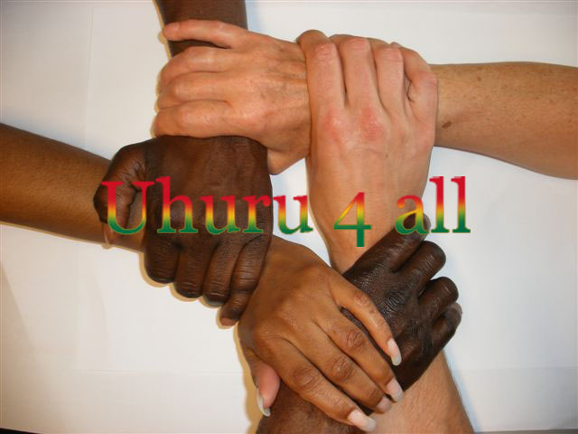

__________________________________________________________________________________
Kamer van Koophandel: 34 27 69 99 Stichting Uhuru4all
Amsterdam Saffierstraat 266
1074 GZ Amsterdam
Email: mariettedeijen@gmail.com
www.Uhuru4all.org

Forword of the Chairman

After starting the course at the new location in Kojo Oku with five (5) new trainees, it was very nice that the Basic Care Foundation, www.basiccareghana.nl, once again gave us a new order to make clothes for the residents in Tamale as a Christmas present at the annual Christmas party.
The orders from residents all around from the area were minimal as it concerned an area still to be developed and the residents still had to get to know / find the NGO. The assignments to make clothes were few and no new students came.
Due to private circumstances, I transferred the work related to the website to the Chairman of the NGO Ghana, who had moved to the US. The website has been transferred to a provider in the US. After a year the website suddenly disappeared and turned out to have been hacked and all the information has gone.
After a long search by the provider in the Netherlands, something has been found.
In 2018 I was able to build a new website with free help from a website builder Daan Weustenraad (https://daan.onl/).

Mariette Deijen
Chairman Foundation Uhuru4all
The Netherlands

Report activities 2014-2020

2013/2014

We started with four (4) students first and after a few months another (1) student was added.
Given that the sewing workshop was located in an area still to be developed, the turnout of trainees was still low.

Partly due to another order from the Basic Care Foundation, there was work.
The assignment was to make clothes for 3500 euro’s for the annual Christmas party in Tamale. The clothing is intended as a Christmas gift for the poorest of the poor. At Christmas, not only clothes were distributed, but also a meal.
550 pieces of clothing, women's, men's and children's clothing were made for the 3500 euros.

2015

In February, an order was first placed for 3,500 euros, and in March an additional order of 1,000 euros was added. The costs of the materials and fabrics became more and more expensive.
This meant resp. 380 pieces of clothing and 170 pieces of women's, men's and children's clothing in various sizes ...

2016

This year the Foundation was given an amount of 4250 euros.
Every year there was consultation with Dr. David and Mariama, his wife, about what clothes should be made and for whom. This year an upgrade of the ladies and menswear has been made. The assignments for the ladies were made more specific, not just simple long dresses, but Patapata’s, top down made of the fabric Woodin (an expensive fabric) and the long dresses of Tie and Dye.
The men's trousers were asked to make of a better quality fabric.
This brought the number of pieces of clothing that could be made for this order to 400.

2017
This year too, the amount was 4,500 euro’s for which 405 pieces of women's, men's and children's clothing were made.
The chairman of the NGO Ghana and the chairman from the Netherlands were simultaneously in September in Ghana and then celebrated the 10th anniversary of the Foundation.
A film has been made of this, which can be seen on You Tube:
https://www.youtube.com/watch?v=9JaQEYMZx0M&t=6s

2018

Once again an order of 4500 euro’s was received for which 405 pieces of women's, men's and children's clothing were made.
Some sponsor organizations have been contacted this year. There is space on the piece of land in front of the workshop, to build another building to create more space for the students and also to start a new Tie and Dye course. All this can be read in the project proposal which is available on the website.

The recycling organization Re-sell then sponsored us with 2000 euro’s, which I transferred to the treasurer in 2019 when I was back in Ghana. A portion of the amount was used to level the ground for the workshop and to dig a trench to counteract the water load of heavy rainfall. The rest of the money is kept for use as soon as the building can be built further.

2019

The costs in Ghana are increasing annually. This year the order was 5000 euro’s and eventually 465 pieces of clothing could be made from this amount.
2020

This year the order has been increased to 5250 euros, which resulted in the number of 466 pieces of clothing.
This shows how fast prices in Ghana are increasing… ..
=====================
All orders from the Basic Care Foundation with the specifications of the clothing made, can be found on the website under Documents.
The payments of the orders of the Basic Care Foundation are transferred directly to the bank account in Ghana.
=======================

Website: www.uhuru4all.org

