**Project: Uhuru Training Centre**

***‘A centre of vocational training for underprivileged young people in Nyanyano/Kasoa,Ghana’***

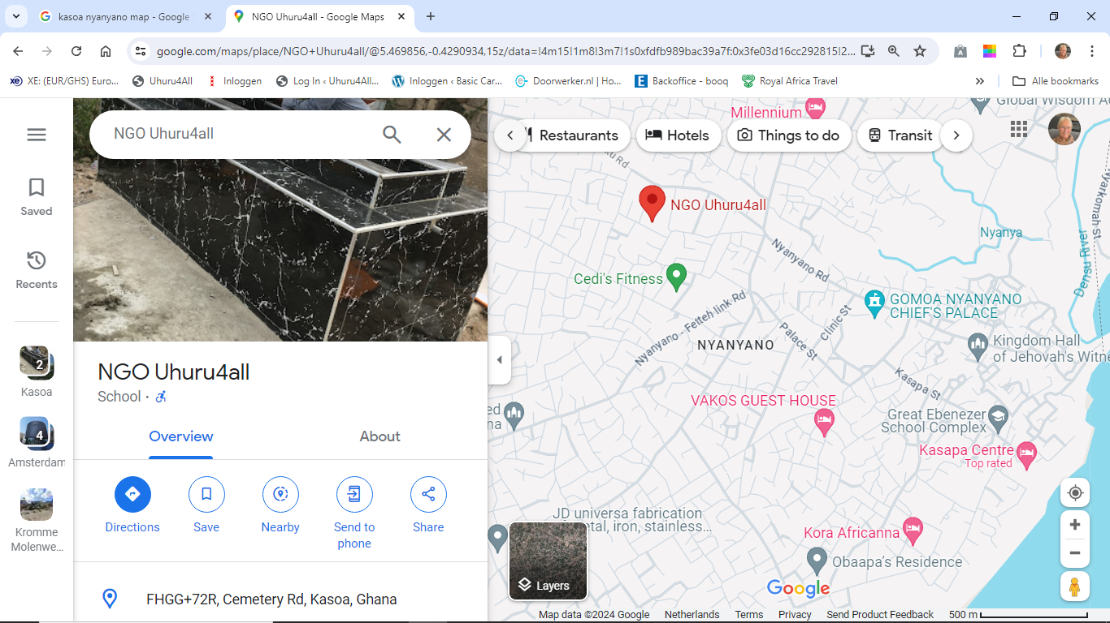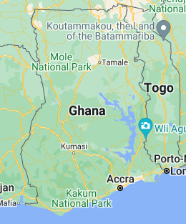

1. Name of project, name of organization
2. Country, region, location of project
3. Summary of the project

* Goals of the project
* Beneficiaries
* Situation regarding training in Ghana
* Solution to this situation

1. Sustainability

* Sustainability of the project

1. Total budget of the project
2. List of other requested sponsors
3. Annual report, financial overview of the running organization/coordinating this project

01-08-2024 Board members Abdul M. Sidiq, chairman

Daniel Anabire Ayamga, treasurer

Erica Abekah, secretary

Naim Suleman, board member

Sakina Ibrahim, board member

Founder NGO uhuru4all Mariette Deijen

1. Name of project, name of organization

Uhuru Training Centre

NGO Uhuru4all

1. Country, region, location of project

The Gomoa East District in the Central Region of Ghana Nyanyano, FHGG+72R, Cemetery Rd, Kasoa, Ghana

1. Summary of the project

* Goals of the project

The goal of the project is to be able to help more young people to get the possibility, next to the sewing vocation, to follow another vocational training, like what we are planning to have: Hairdressing; Manicure & pedicure; Backing.

After accomplishing the training they will do an official exam at the *NVTI and be able to start their own business and earn money to sustain their selves and support their family….

* Beneficiaries

The number of trainees, who can follow the hairdressing, will be 15. The duration of the training is three (3) years.

The number of trainees who can follow the manicure and pedicure training is 15.

This training is six (6) months

The number of trainees to follow the backing training will be 20.

The training is one (1) year

* Situation regarding training in Ghana

When it comes to vocational training In Ghana, The *NVTI is given a lot of different vocational training courses. Unfortunately most of the youngsters can’t afford a training at the *NVTI. That is why we came in, in the beginning with a sewing vocation. Now we want to add three other training courses. We noticed that the interest and the length of the sewing training sometimes is an obstacle. Youngsters very often have to help their parents to get some income with selling goods. That is the reason why we choose new vocational training courses.

* Solution to this situation

The solution is to offer more other training courses which doesn’t cost much.

To start the training they have to be able to bring some items for the training.

All is noted on the document of the different training courses.

1. Sustainability

* Sustainability of the project

The sustainability of the three training courses will be a fact, since we are going to work with customers.

We are working in a circle. The teacher teaches the trainees, the trainees find the customers to learn their skills of the training; the teacher gets the money of the customers, who will pay a lower price than in a regular shop. The Ghanaian women love to do their hair and nails and everybody has to eat.

90 % of the money which comes in goes to the teacher, 10 % will be used for new items for the training!

1. **Total budget of the project is Ghs 325,000**

* attached the estimate of the building: Ghc182,000
* attached the list with items and prices for the Hairdressing: GHc 40,000

Manicure and Pedicure training Ghc 20,000

* attached the list with items and prices for the Backing training: Ghc 27,000
* attached the estimate of the solar panels: Ghc 32.000
* Rainwater tank incl pipes Ghc 8,000
* unforeseen Ghc 16,000

**Total Ghc 325,000.00**

1. Annual report, financial overview of the running organization/coordinating this project.

Yearly the sewing vocation training receives an order of the Basic Care Ghana (basiccareghana.nl)

the Netherlands since 2008. It started with an order of 6.500 GHc/500 euro.

The last order is GHc 83.398/ 6500 euro.

Some extra income comes from customers, but that isn’t enough to have some many trainees.

The estimates of the last three years are attached to this email.

This is the only yearly financial overview of in- and outcome of the NGO Uhuru4all. The costs of official documents or other passing costs are paid by the Founder of the NGO.

When you like to know what happened from the start in 2007 and how many trainees followed, dropped out or finished the training with an *NVTI certificate, look at our website:

[**uhuru4all.org**](https://uhuru4all.org)

**THANK YOU!**

*NVTI: National Vocational Training Institute